Lab 3: Bacteria & Protists
This week in lab we will study prokaryotic bacteria and eukaryotic protists.
Our goals are to:
- Study cyanobacteria, a complicated bacterial species that can both feed and poison us and our environment!
- Explore the diversity of protists from single celled diatoms to multicellular giant kelp we find in Oregon’s intertidal zones and washed ashore on our beaches.

Bacteria
The word “bacteria” may make people want to reach for the hand sanitizer. But as we saw in lecture, our microbiome is critical to our health. Bacteria can also be healthy food and are critical for ecosystem health.

Cyanobacteria
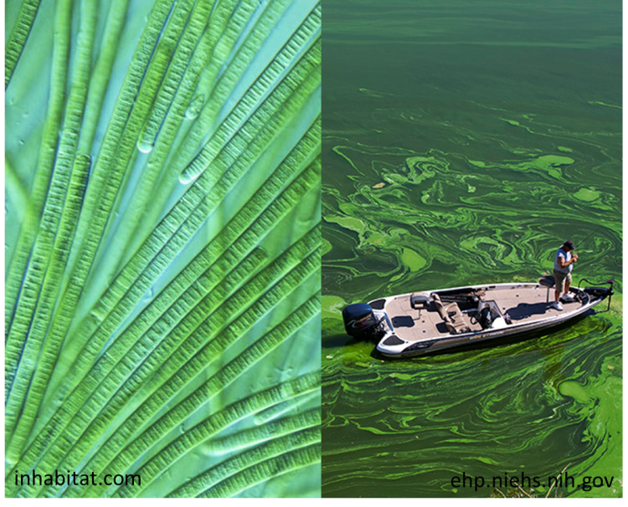
Cyanobacteria, sometimes referred to as “blue-green algae”, are actually a phylum of prokaryotic bacteria – not eukaryotic algae!
Figure 1. Aphanizomenon flos-aquae, a colonial filamentous species in the phylum cyanobacteria which grows in Upper Klamath Lake and can create huge blooms. The microscopic picture on the lower left shows a filament with the larger nitrogen-fixing heterocysts. Clumps of these filaments are visible to the naked eye in the upper left. Don’t let your dog, or yourself ingest water from these large blooms, it can be toxic!
I should mention here that the term “algae” is used to refer to organisms that are aquatic and manufacture their own food and may include species of the Chromista, Rhodophyta, and photosynthetic bacteria, even though they are distantly related.
Cyanobacteria are photosynthetic organisms and although they are typically unicellular, they often grow in colonies large enough to see with the naked eye. Colonies of Aphanizomenon flos-aquae, a species of cyanobacteria, can be seen in Upper Klamath Lake. It is harvested and sold as a dietary supplement for dietary protein, B-vitamins, and iron. These cyanobacteria is an important part of our local economy! Check out this local companies website and their short video http://www.klamathbluegreen.com (this is not an endorsement of this company or the product). However, massive blooms of cyanobacteria in Klamath Lake can ultimately starve the lake of oxygen as the dead cyanobacteria decompose. This have negative impacts on native and endangered fish such as the lost river and short nose sucker. Aphanizomenon flos-aquae is also known to produce endotoxins, toxic chemicals released when cells die. Once released (lysed), and ingested, these toxins can damage liver and nerve tissues in mammals.
Cyanobacteria are the oldest known fossils, more than 3.5 billion years old, and they are one of the largest and most important groups of bacteria on earth. They generated the earth’s oxygen rich atmosphere during the Great Oxidation Event of the Archaean Eon (Precambrian supereon) and played a key role in the evolution of plants through endosymbiosis. Cyanobacteria get their name from the bluish pigment phycocyanin, which they use to capture light for photosynthesis. They also contain chlorophyll a, the same photosynthetic pigment in plants. In fact, the chloroplast in plants is a symbiotic cyanobacterium, taken up by a green algal ancestor of the plants sometime in the Precambrian. Not all "blue-green algae" are blue; some common forms are red or pink from the pigment phycoerythrin. The Red Sea gets its name from occasional blooms of Oscillatoria.
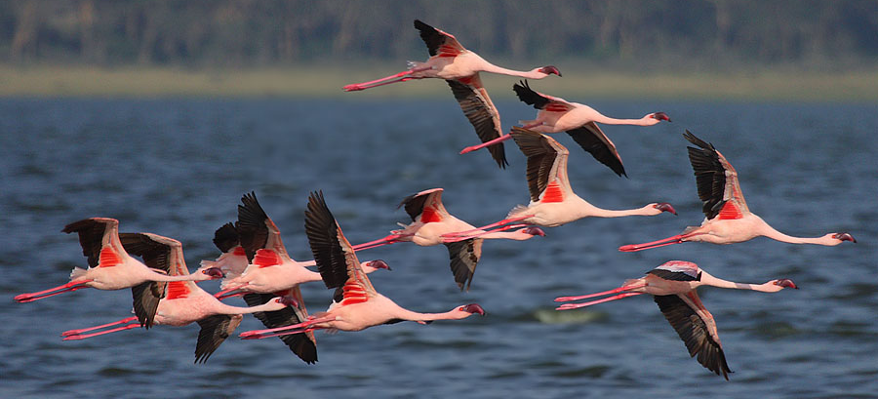
Lesser Flamingos (Phoeniconaias minor ) in Africa get their pink color from their primary food source Spirulina plantensis, a species of cyanobacteria which contains carotenoids (Kaggwa et al 2013). Cyanobacteria also have symbiotic relationships with fungi, providing the photosynthetic autotroph component of lichens.
Figure 2. Lesser Flamingos get their pink color from their food, a species of cyanobacteria called Spirulina plantensis. (Photo: www.seduniatravel.com)
Cyanobacteria remain important to plants today through their ability to fix nitrogen. They are one of the few organisms that can convert inert atmospheric nitrogen into an organic form, such as nitrate or ammonia. It is these "fixed" forms of nitrogen which plants need for their growth, and must obtain from the soil. Many plants, especially legumes, have formed symbiotic relations with nitrifying bacteria, providing specialized tissues in their roots or stems to house the bacteria, in return for organic nitrogen. This process of fixing nitrogen, called nitrification cannot occur in the presence of oxygen, so nitrogen is fixed in specialized cells called heterocysts. These cells have an especially thickened wall that contains an anaerobic environment. You can see these larger cells among the filaments of Nostoc.
- What is the name of the ancient Australian fossil deposits of cyanobacteria we saw in lecture?

- Don’t remember the answer to #1? Check out this website http://www.ucmp.berkeley.edu/bacteria/cyanofr.html . Are these fossil structures still being formed today? Where would you go to see them?

- As the enzyme responsible for nitrogen fixation (nitrogenase) is highly sensitive towards oxygen, nitrogen fixation and oxygenic photosynthesis cannot take place simultaneously in cyanobacterial cells. Read this short abstract and key concepts http://www.els.net/WileyCDA/ElsArticle/refId-a0000306.html . What does it mean that cyanobacteria use “division of labor” to solve this problem?

- Are these unicellular or multicellular organisms based on this reading?

Protists
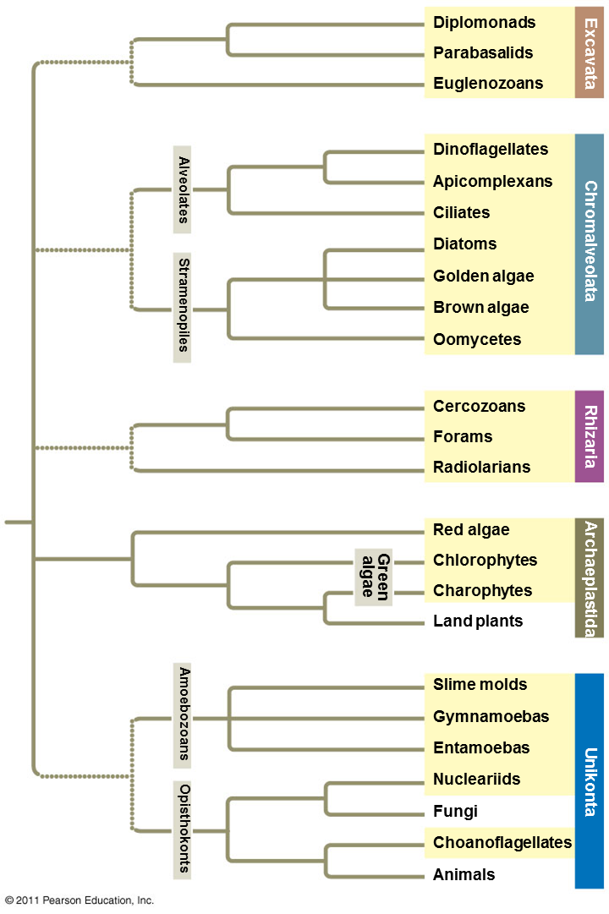
In recent years, eukaryotes have been broken down into four kingdoms: animals, plants, fungi, and protists. The first three kingdoms are monophyletic groups, but the "Kingdom Protista" is not monophyletic; it contains organisms which are more closely related to members of other kingdoms than they are to other protists. Recent studies of protist DNA and ultrastructure has shown that the protists are far more diverse than had been previously expected; they probably should be classified in several kingdom-level taxa. We retain the word "protist" as a convenient term to mean "eukaryote that isn't a plant, animal, or fungus."
In lecture we considered 5 “supergroups” of protists, shown in the phylogenetic tree below: Excavata, Chromalveolata, Rhizaria, Archaeplastida, and Unikonta. While the first three groups contain all protists, the last two include the kingdoms of plants, fungi, and animals. As we said earlier, this means that some protists are more closely related to other kingdoms that they are to other protists. For example, Charophytes are most closely related to plants and Choanoflagellates are more closely related to Animals.

EXCAVATA: Euglenozoans
In the Excavata supergroup are the Euglenid protists which represent about 1,000 known species. They are unicellular and have a one or two long whip-like flagella used for locomotion. Euglenids can be both autotrophic and heterotrophic energy capture (called mixotrophs). Many Euglena have photosynthesizing chloroplasts within the body of the cell like plants. They can also surround a particle of food with their contractile vacuole and consume it by phagocytosis, like animals. Euglenids lack a cell wall; instead they have a flexible protein structure called a pellicle that allows the organism to change shape and contract. When food is scarce, or there is low moisture, some euglenids form a protective wall around itself and remain a dormant cyst until conditions improve. Most known euglenids live in shallow freshwater habitats enriched in organic matter, but some live in marine or brackish waters and a few are parasitic in animals.
Check out this video microscopy of Euglenids, they are actually quite beautiful! https://www.youtube.com/watch?v=IWyol3u-OL8
- Based on the figure below, what parts of the Euglena anatomy can you spot in the video? Circle them on the figure below (Image: Dreamstime.com) You can use the line drawing or the circle tool under Insert > Shapes).
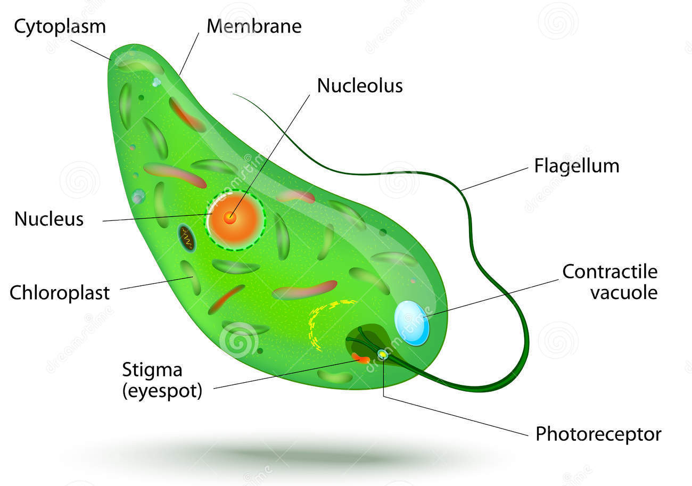

CHROMALVEOLATA: Cilliates
Cilliates are in Chromalveolata supergroup. In contrast to Euglena, they have many small cilia rather than a flagellum. Watch this amazingly detailed video microscopy film of paramecium and answer the question below https://www.youtube.com/watch?v=sn3MTYNe8mM
- Describe the autotrophic process by which paramecium can feed.

CHROMALVEOLATA: Diatoms
Diatoms are extremely diverse unicellular photosynthetic algae and they are a critical component of the oceans phytoplankton communities, although diatoms also inhabit fresh water and soils. They belong to the proposed kingdom-level taxon Chromista.
Watch this Science Nation video and answer the following questions. https://www.youtube.com/watch?v=7n-0iWM_lWM
- What are the cell walls of diatoms comprised of?

- How can they be used as indicators of climate change?

- How might terrestrial plants affect diatoms?

CHROMALVEOLATA: Brown algae
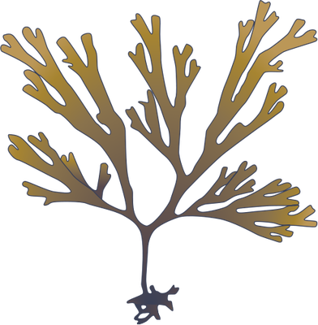
Brown algae, the Phaetophyta, are the largest of the Chromists. Giant kelp can be over 30 meters long, while diatoms are only forty millionths of a meter long! Originally classified as plants, phaetophytes are not closely related to plants at all. Although they are photosynthetic autotrophs, they have different pigments such as chlorophyll c and fucoxanthin which reflect yellow light. Like plants and many protists, brown algae undergo a complex life cycle involving alternation of generations. Check out this video on kelp forests of California from bbc http://www.bbc.co.uk/nature/life/Macrocystis#p00dhlr0 .
- How fast can giant kelp grow?

- What mistake does the narrator (David Attenborough) make early in the video when referring to the kelp?

Now watch this short video from NOAA, the National Oceanic and Atmospheric Administration http://oceantoday.noaa.gov/underwaterforests/
- How do the algae reach towards the sun rather than flop on the sea floor?

Our las video is from Jean-Michel Cousteau http://www.pbslearningmedia.org/resource/kqed07.sci.life.eco.kelp/kelp-forest/
- Are the main structures of the kelp homologous or analogous to structures in plants?

- Explain the relationship between kelp, otters, and urchins.

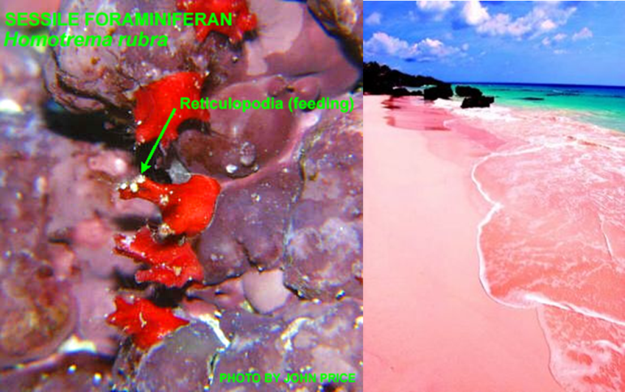
RHIZARIA: Forams
Foraminifera (forams for short) are single-celled protists with shells, called tests made of organic compounds, sand grains and other particles cemented together, or crystalline calcite. The pink sands of Bermuda are formed from the shells of Homotrema rubrum, a forman with pink shells.
Some species consume dissolved organic molecules, while others prey on bacteria, diatoms and other single celled phytoplankton, small copepods - which are animals! They use thin extensions of their cytoplasm called reticulopodia to move and catch their food, similar to the pseudopodia of an amoeba, although much more numerous and thinner.
Figure 3. The fomaniferan Homotrema rubrum and their reticulopodia used for feeding. Their red shells form the "pink sand" beaches of Bermuda. Who's ready to hit the beach?!
The chemistry of forman shells provides insight into the chemistry of the water in which they grow. In particular, the ratio of stable oxygen isotopes depends on the water temperature. The lighter isotopes evaporate at a greater rate in warmer water.
Watch this video on research using diatoms and formans to understand Antarctica’s climate history and answer the following questions. https://www.youtube.com/watch?v=Xl75ChKPlj8
- How do the micropaleobiologists use diatoms to study Antarctica’s climate history?

- How are they using fossil foraminifera?

ARCHAEPLASTIDA: Red Algae & Green Algae
The Archaeplastida is comprised of the red algae (Rhodophyta), the green algae and the land plants. The chloroplasts of all these organisms are surrounded by two membranes, suggesting they developed directly from endosymbiotic cyanobacteria, which we studied earlier. There is continuing debate whether this group is monophyletic (Kim & Graham 2008; Nozaki et al. 2009), a discussion that is outside the scope of our class.
GREEN ALGAE represent a paraphyletic group which excludes the Plantae and is comprised of two phyla, the Chlorophytes and Charophytes. Like plants, green algae contain both chlorophyll a and b.
RED ALGAE are in the phylum Rhodophyta. They are one of the oldest and most diverse groups of algae with an estimated 4,000-10,000 species (Woelkerling 1990; Thomas 2002). One of the oldest fossil red alga is Bangiomorpha pubescens dating 1.2 billion years old!
- Based on the phylogenetic tree at the beginning of the lab, which group of green algae are the closest relatives of plants?

- Check out this video of a Galapagos marine iguana feeding on algae – its primary food source. How many types of algae do you see it feeding on? http://www.arkive.org/galapagos-marine-iguana/amblyrhynchus-cristatus/video-08b.html
JUST FOR FUN: Iguanas aren’t the only animals that eat seaweed. Check out this video from the Foodie channel on foraging for and cooking with seaweed https://www.youtube.com/watch?v=rqfPH2aawvM

- Are algae the answer for future bio-energy? Check out this TED talk by Jonathan Trent for details on producing microalgae for biofuels and other products. http://www.ted.com/talks/jonathan_trent_energy_from_floating_algae_pods?language=en
What do you think?

UNIKONTA: Choanoflagellates
Unikonta is a large supergroup containing protist groups as well as fungi and animals! Within the opisthokont clade are the animals and an obscure class of organisms the choanoflagellates. If they are so obscure, why are we studying them? Well, they may be the closest living ancestors of all metazoans (animals)! That’s right! A choanoflagellate could be your great, great, great, great, great, great, great ….grandmother. Below is a link to an excellent lecture by Nicole King, a professor at UC Berkeley Howard Hughes Medical Institute on Choanoflagellates and the origin of multicellular animals.
There are many groups of multicellular organisms – plants, fungi, protists, animals – and it appears that multicellularity evolved multiple times. One line of support for this comes from the fact that while all of these groups share genes for basic cell function, like DNA replication, they do not share genes for the interaction of cells. Therefore, multicellularity likely evolved multiple times and is thus an example of convergent evolution! This leaves the question, how did multicellularity evolve in animals? Dr. King explains how choanoflagellates – single celled protists – may hold the answer.
Watch Dr. King’s lecture from minute 8:10 through minute 18:23 and answer these questions. (You are welcome to watch the entire lecture, it is extremely interesting). https://www.youtube.com/watch?v=1v6cgSkiHik
- What types of evidence are there for the hypothesis that choanoflagellates are the sister taxa of metazoans?

- What are the 3 main parts of choanoflagellate anatomy?

- What 2 main functions does the flagellum play?

- Based on the research of 19th century scientist William Savillve-Kent, explain the link between choanoflagellate cells and metazoans.

- What did the first multicellular animals likely eat?

Literature cited
Kaggwa, M. N., Gruber, M., Oduor, S. O., & Schagerl, M. (2013). A detailed time series assessment of the diet of Lesser Flamingos: further explanation for their itinerant behaviour. Hydrobiologia, 710, 83-93.
Kim, E., & Graham, L. E. (2008). EEF2 analysis challenges the monophyly of Archaeplastida and Chromalveolata. PLoS One, 3, e2621.
Nozaki, H., Maruyama, S., Matsuzaki, M., Nakada, T., Kato, S., & Misawa, K. (2009). Phylogenetic positions of Glaucophyta, green plants (Archaeplastida) and Haptophyta (Chromalveolata) as deduced from slowly evolving nuclear genes". Molecular Phylogenetics and Evolution 53, 872–80.
Thomas, D. (2002). Seaweeds. Life Series. Natural History Museum, London.
Woelkerling, W. J. (1990). An introduction. In K. M. Cole & R. G. Sheath. Biology of the Red Algae. Cambridge University Press, Cambridge. pp. 1–6.

